

**Vietnam Forests and Deltas Program**

A FIELD REPORT

FUELWOOD VALUE CHAIN ASSESSMENT

IN THANH HOA & NGHE AN PROVINCES

**Prepared by XXXXX**

**Submission date: XX/XX/XXXX**

*This publication is made possible by the generous support of the American people through the United States Agency for International Development (USAID). The contents are the responsibility of Vietnam Forests and Deltas Program and do not necessarily reflect the views of USAID or the United States Government.*

**CONTENTS**

Executive Summary 3

1 Introduction 5

2 Method 5

2.1 Clustering design 6

2.2 Field survey 11

2.3 Data processing and analysis 13

2.3.1 Data processing for household survey 13

2.3.2 Data processing for industrial and commercial fuelwood survey 14

2.3.3 Data processing for fuelwood using for pig raising 15

3 Findings 15

3.1 Fuelwood demand 15

3.1.1 Household fuelwood demand 15

3.1.2 Industrial and commercial fuelwood demand 30

3.1.3 Total fuelwood demand in Thanh Hoa and Nghe An 41

3.2 Sustainable fuelwood supply 42

3.2.1 Estimation of fuelwood production by forest type 42

3.2.2 Fuelwood supply estimation for Thanh Hoa and Nghe An 43

3.3 Key factors driving forest degradation 45

3.4 Value chain of fuelwood 46

4 Recommendations 47

4.1 Urgent need for revision of land conversion in some specific area 47

4.2 Urgent need for forest land administration in some specific area 48

4.3 Promotion of biogas for the households that raise more than 10 pigs 48

4.4 Improved stoves 48

4.5 Stability of electricity supply 49

4.6 Promotion of electricity-saving cookers and LPG cookers 49

4.7 Potential of using agriculture residues as an alternative to fuelwood 49

4.8 Creation of fuelwood source 49

4.9 Further investigation of local industrial fuelwood demand 49

# Executive Summary

This report provides the findings on fuelwood demand and supply in Thanh Hoa and Nghe An to identify the key drivers driving deforestation and forest degradation. It also provides understandings to value chain of the fuelwood, and identifies key actors of the chain.

The fuelwood demand comes from two major sectors: 1) residential sector including cooking demand and supplement jobs; and 2) commercial and local industrial sector in which all commercial activities of fuelwood logged from local forest are to supply to local industries. For each sector, the demand is different by source of fuelwood (natural forest, plantation forest, and home garden), and by quality (or size) of fuelwood (larger wood of size > 15cm in diameter, small wood of size 5-15cm, and branches of less than 5cm).

The fuelwood supply comes from three major sources: natural forest, plantation forest, and home garden. The report provides the estimation of sustainable fuelwood supply by each source.

Comparing the demand and the sustainable supply of fuelwood is to calculate the deficit in supply. Further analysis of source and size of fuelwood is to identify major cause of large size of tree in natural forest which is the key driver driving forest degradation.

Value chain analysis helps identifying the key actor that involve in fuelwood consumption, and how income is distributed in the chain.

General findings of this research are:

1. The total fuelwood demand for households of Thanh Hoa and Nghe An is estimated at 1.6 million tons per annum in which about more than 1.4 million tons is used for residents’ cooking and about 174,000 tons is used for pig raising.
2. .
3. The total sustainable fuelwood supply for Thanh Hoa and Nghe An is estimated at 1,9 million ton per year, of which 1,1 million ton are from natural broad leaf forest.
4. This supply can fulfill the major of 96% of fuelwood demand for size less than 15cm of the households.

Recommendations for fuelwood supply – demand assessment are specific suggestions for the activities to implement within the scope of VFD program. These recommendations include:

1. Revision of land conversion plan in which natural forest is vastly converted into plantation forest. This converstion create two incomes for farmers: 1) exploitation of natural tree to prepare empty land for plantation; and 2) plantation of material wood which is currently selling at higher price compared to fuelwood. This is vastly cause forest degradation.
2. Supporting forest land management by issuing land certificate with specific map for shifting cultivation land.
3. Promotion of improved stove to the households that have supplement jobs which consume fuelwood.
4. Promoting use of agriculture residues to replace fuelwood for cooking.
5. Creating of fuelwood source is a long-term sustainable method to balance fuelwood demand and supply.
6. Further investigation in local industrial demand for fuelwood and material wood to clearly identify key drivers driving forest degradation.

# Introduction

Vietnam is a developing country with 70% population living in the rural area, about three fourth of the land is located in the hilly and mountain area with long tradition of fuelwood as a main source of energy. Fuelwood are used in the households for cooking, heating and support to supplement business like alcohol brewing, food processing.

Woody biomass from forest is a renewable source of energy that can substitute for fossil fuels in the production of energy and other products, a potentially important tool in the national strategy to reduce greenhouse gas emissions. However as the rural population is continuously increased, the tradition of heavily dependence on fuelwood may increase the pressure on forest and thus lead to forest degradation and deforestation.

Understanding the dimension of fuelwood consumption, the structure and relationship of key stakeholders in the fuelwood supply and demand, and the consequences can help policy maker to design better energy supply system for rural population, mitigate the global warming and to reduce forest degradation and deforestation.

This study, funded by Vietnam Forests and Deltas project (VFD), is aiming to assess current situation and future trends of fuelwood consumption and exploitation, the value change of fuelwood and its relationship with forest degradation and deforestation, and identify key opportunities to design intervention that could lead to more effectively and sustainably use of fuelwood in the project area.

The study was conducted in 2 provinces Thanh Hoa and Nghe An during September 2014. At industrial level, the consultant team have surveyed several industrial factories that are using wood as fuel in two provinces. At community level, the consultant team conducted interviews with 215 households at 14 communes including 4 districts in Thanh Hoa and 3 districts in Nghe An. Interviews with local officers were also conducted to collect information on social economic condition, current regulation/ policy in forest protection and how it was enforced at local level.

This report present our findings in fuelwood demand side at household level, industrial level, and commercial activity of fuelwood. Finally the value chain of fuelwood and its relationship with forest degradation and deforestation is analyzed and discussed.

# Method

The field study was conducted from 18 to 26 August 2014. Before starting the field survey a desk review was carried out to collect information on the social economic condition as well as the forest resources of the study area. Key secondary data collected at commune level during the desk review are: population density, forest area, data related to climatic condition such as temperature and elevation. It contributed to design the questionnaire and number of samples.

A total of 221 households were selected using stratified random sampling procedure. The process of household selection includes: i) selection of cluster; ii) selection of commune from clusters; iii) selection of village from commune; iv) selection of households from village.

The reason to use cluster instead of district to start the selection process is that districts boundary are administrative unit that might not follow nature landscape and social economic condition that drive the behavior of fuelwood consumption. Therefore the design of survey starts firstly with clustering the study area into several stratums (clusters) that are homogenous in term of fuelwood consumption.

## Clustering design

For fuelwood consumption survey, it is recommended to use stratified sampling rather than simple random. This is because we know that the studied population can be physically divided in to homogenous groups with respect to biomass consumption. The stratified sampling, therefore, will lead to greater accuracy in the estimates of fuelwood consumption patterns (smaller estimation errors than simple random sampling with the same sample size).

For this study, following variables are used for stratification.

Table 1. Variables used for sample stratification

|  |  |  |
| --- | --- | --- |
| **Variable** | **Relation to biomass consumption** | **Data source** |
| Population density 2010 | Basic demographic characteristic, reflect the demand size of biomass consumption. | MONRE 2010 - Commune level population density |
| Mean elevation | Geographic character of a population in relationship with biomass source and consumption. People living in higher altitude usually consume more fuelwood for heating | Global ASTER Digital elevation model, resolution 30 m. Computed as mean value for each commune |
| Mean slope | Reflect the terrain condition and accessibility | Global ASTER Digital elevation model, resolution 30 m. Computed as mean value for each commune |
| Distance to road | Reflect the level of access to transportation | Distance to national road, inter-provincial road, inter-district road. Computed as mean value for each commune |
| Average annual temperature | Area with lower temperature would need more fuelwood for heating and cooking | WorldClim, global climate data at 1 km resolution. Computed as mean value for each commune |
| Min temp of coldest month | Area with lower temperature would need more fuelwood for heating and cooking | WorldClim, global climate data at 1 km resolution. Computed as mean value for each commune |
| Cover % of natural forest area | Reflect the source of fuelwood | MARD, National forest inventory 2010, available at provincial level |
| Cover % of plantation forest area | Reflect the source of fuelwood | MARD, National forest inventory 2010, available at provincial level |

All of the above information is extracted for each commune in Thanh Hoa and Nghe An. To classify all commune in the study area into homogenous group, the K-mean clustering method is employed. This procedure uses non-hierarchical clustering of observations according to MacQueen's algorithm[1]. The result of this process is 6 clusters of commune that are similar in term of biomass consumption (Fig1 and Fig 2). After some initial analysis of the clustering result, it was found that the size of cluster 1 is very small compare to other clusters. Cluster 1 represent communes and wards with very high population density that are mainly located in city and big towns. This area is not the target of this study, therefore it was decided to exclude cluster 1 from the sampling scheme.

Table 2. Characteristics of cluster

|  |  |  |  |  |  |  |  |
| --- | --- | --- | --- | --- | --- | --- | --- |
| **Cluster** | **Avg. area of natural forest (ha/person)** | **Avg. area of plantation forest (ha/person)** | **Avg. ratio of natural forest by commune (%)** | **Avg. ratio of plantation forest (%)** | **Avg. elevation (m)** | **Avg. annual temperature (C deg)** | **Avg. temperature of the coldest month (C Deg)** |
| 1 | 0.000 | 0.00 | 0.0 | 0.7 | 12.2 | 21.7 | 13.9 |
| 2 | 0.000 | 0.00 | 0.1 | 1.8 | 14.2 | 24.3 | 14.4 |
| 3 | 0.021 | 0.06 | 4.0 | 20.1 | 46.9 | 24.2 | 14.3 |
| 4 | 0.058 | 0.09 | 10.1 | 19.6 | 84.4 | 24.1 | 14.0 |
| 5 | 0.925 | 0.11 | 49.2 | 7.9 | 293.6 | 23.0 | 12.4 |
| 6 | 2.262 | 0.11 | 54.6 | 3.8 | 669.1 | 20.9 | 10.0 |

Looking at key parameters of the cluster (Table 2) it can be seen that cluster 1 to 6 is spreading from delta (cluster 1 and 2) to forest and mountain area (cluster 5 and 6) with cluster 3 and 4 representing the hilly area in between. The elevation of the cluster reflect this pattern very clearly. The distinct characteristic of cluster 5 and 6 is that the coverage of natural forest is very high, 49.2% and 54.6% respectively. People in these clusters have easy access to natural forest and consequently easy access to high quality fuelwood.

In cluster 3 and 4 the most important character is the high coverage of plantation forest, 20.1% and 19.6% respectively. Cluster 2 and 1 has almost no natural forest and very little plantation forest.

A brief description of each cluster is presented below:

Table 3. Description of cluster

|  |  |  |
| --- | --- | --- |
| **Cluster** | **Interpretation** | **Forest to Delta Characteristics** |
| Cluster 6 | Highest mountainous area, highest coverage of natural forest, less coverage of plantation forest, farthest to main truck roads, lowest temperature of the medium coldest month temperature, lowest population density | Forest |
| Cluster 5 | High mountainous area, high coverage of natural forest, more plantation forest, closer to main truck roads, many depressed communes, less cold, higher population density |  |
| Cluster 4 | Low mountain and hills, less natural forest coverage, high plantation forest coverage, close to main truck roads, less depressed communes, less cold, population density increase significantly. |  |
| Cluster 3 | Major hills and flat land, almost no natural forest, most plantation forest coverage, very close major roads, almost no depressed communes, not cold, high population density |  |
| Cluster 2 | Delta land, no natural forest, few plantation forest, closest to major roads, warmest, highest population density | Delta |

Map of these clusters inThanh Hoa and Nghe An are as below:

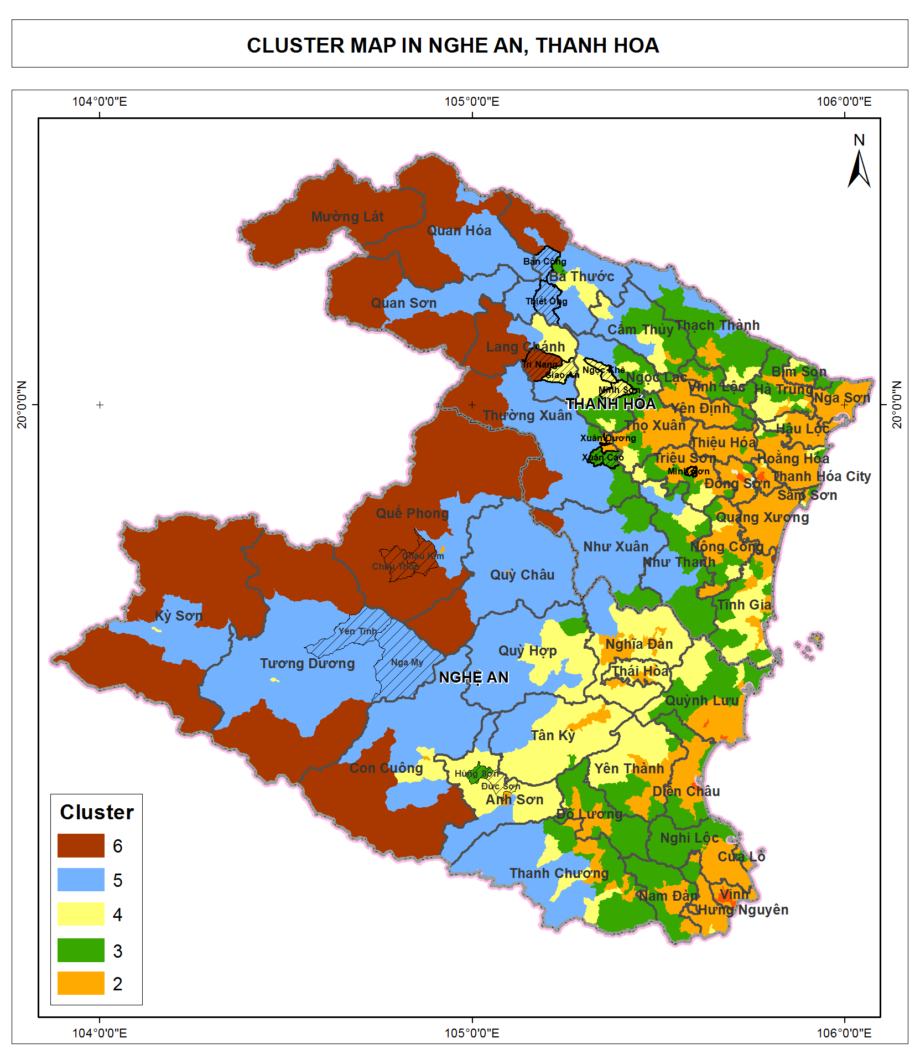

Figure 1. Map of cluster in Thanh Hoa and Nghe An

Once the clusters were identified and characterized the communes were selected with advice from provincial VFD officers so that each cluster have at least one communes. The list of commune selected for field survey is presented in Table 4. From each commune, one village is selected with the advice of the commune PPC. From each village, about 15 household is selected with the advice of village’s head so that they represent different type of economic condition: poor household, rich households, household with and without pig raising.

Table 4. List of commune selected for field survey

|  |  |  |  |  |
| --- | --- | --- | --- | --- |
| **STT** | **Province** | **District** | **Commune** | **Cluster** |
| 1 | Thanh Hóa | Bá Thước | Thiết Ống | 5 |
| 2 | Thanh Hóa | Bá Thước | Bản Công | 5 |
| 3 | Thanh Hóa | Lang Chánh | Giao An | 4 |
| 4 | Thanh Hóa | Lang Chánh | Trí Năng | 6 |
| 5 | Thanh Hóa | Ngọc Lặc | Minh Sơn | 4 |
| 6 | Thanh Hóa | Ngọc Lặc | Ngọc Khê | 4 |
| 7 | Thanh Hóa | Thường Xuân | Xuân Dương | 2 |
| 8 | Thanh Hóa | Thường Xuân | Xuân Cao | 3 |
| 9 | Nghệ An | Anh Sơn | Hùng Sơn | 3 |
| 10 | Nghệ An | Anh Sơn | Đức Sơn | 4 |
| 11 | Nghệ An | Tương Dương | Yên Tĩnh | 5 |
| 12 | Nghệ An | Tương Dương | Nga My | 5 |
| 13 | Nghệ An | Quế Phong | Châu Kim | 6 |
| 14 | Nghệ An | Quế Phong | Châu Thôn | 6 |

In this selection of sample, cluster 2 is represented by only 1 commune. Cluster 2 has more population, higher population density. But the size of sample is smaller because VFD PPMU suggested that survey should be conducted in high land area where there are more forest coverage and more project activities.

|  |  |  |  |
| --- | --- | --- | --- |
| Geographic area | Population (person) | Natural forest area (ha) | Plantation forest area (ha) |
| Thanh Hoa and Nghe An | 6,501,383 | 1,037,561 | 216,659 |
| Cluster 6 | 245,812 | 513,817 | 22,734 |
| Cluster 5 | 539,052 | 455,911 | 53,826 |
| Cluster 4 | 824,786 | 43,159 | 58,844 |
| Cluster 3 | 1,357,861 | 24,048 | 73,820 |
| Cluster 2 | 3,241,477 | 625 | 7,344 |
| Cluster 1 | 296,573 | 0 | 90 |

## Field survey

***Household fuelwood consumption***

A questionnaire is designed for household interview. The questionnaire include 5 parts, each part include quantitative and qualitative questions. It is designed that some questions are asked for verify answers of other questions. The 5 parts are:

* Part I: General information about household demography, their major income making activities that relate to creating fuelwood or consuming fuelwood. These activities include agriculture cultivation/ afforestation/ pig raising/ alcohol cooking/ other supplement jobs that consume fuelwood. This part also includes questions about the species of forest plantation, and the age of the plants. This is to verify their answers about the source of fuelwood that they are consuming, as in many cases people are reluctant to admit that they collect wood from natural forest. For example:
  + If the answer about the source of fuelwood is that 100% of their fuelwood are from plantation forest, while their plants are acacia at the age of 8 years, then the answer is not verified because it would not be true that the person would go into the acacia forest for every few days and cut some 8 year-old acacia trees for their biomass energy need. The 8 year-old acacia could be sold for paper material for higher price while they can cut tree from natural forest for free, not to mention cutting tree in natural forest is legal or not. The method for harvesting acacia is that they harvest hundreds of acacia for one time, at the age of 5-6 years old and more. Therefore they harvest acacia every several years, not every several days while fuelwood for cooking is a daily need. By the time they harvest acacia (once every several years), they can collect acacia bark for and tops for fuelwood. But this activity cannot be done on a daily or weekly basis.
  + If the answer about the source of fuelwood is that 80% are from bamboo, for a family of 4 persons which has 2 hectare of bamboo plantation forest, then the answer is accepted because the method they harvest bamboo is that they can cut one to several trees in a time. After they cut several bamboo trees, they can collect about 0.5-1m of the bamboo trunk above the ground which is left after selling.
* Part II: Information about fuelwood consumption amount; other alternative biomass options; size of fuelwood; other alternative energy options such as electricity and LPG; and the trend in fuelwood consumption whether it is increasing or decreasing.
  + Although a question is designed for estimation of fuelwood consumption for heating purposes, the data collected cannot be verified and might not be accurate because at the time of survey of August, no household is using fuelwood for heating.
* Part III: Information about fuelwood collection on how often they collect wood, and the amount of wood for each time they collect wood. Distance for wood collection and time amount for wood collection is to verify the data on amount of each time they collect wood. The answer about amount of wood collected each time and collection frequency is to verify their answer about fuelwood consumption amount. This part also include questions on the trend of availability/ scarcity of fuelwood.
* Part IV: Information about selling wood. This is to understand the fuelwood demand of other sectors.
* Part V: Information about improved stove. This is to understand their actual need for fuelwood saving.

For each commune, one village is introduced by commune officer for household interviews. The criteria for the the commune officer to introduce the village is that the village should be of average income compared to the whole commune.

At each village, at least 15 households introduced by the village head participated in the interview. The selection of household is random by the village head. Given an average village have about 100 to 150 households, the sample size of 15 household for one village were considered as sufficient.

Commune officers (including people’s committee’s representative and/or forest rangers) were interviewed to find out the trend of household fuelwood consumption in the past and near future.

Two restaurants and one primary school were visited for further understanding of residential demand for fuelwood.

***Local industrial consumption***

Seven local industrial plants including three in Thanh Hoa and four in Nghe An were visited for interview and observation for fuelwood demand, including: 3 paper mills, 1 MDF, 1 wood chipper and 2 tea plants. Patterned of fuelwood consumption at industrial plan were collected using a semi-structured interview. Key information and questions to be investigated are:

* What is the major product of the plant
* What is the installed capacity
* What is the actual capacity
* The type of thermal equipment: furnace, boiler.
* Type of fuel: fuelwood, coal, oil.
* Quantity of fuel use per day.
* Price of fuel: current and historical; comparison with alternative fuel.
* Trend of fuel demand, future plan for fuel switch and reason.

***Wood middlemen investigation***

The consultant team visited two middlemen, one in Thanh Hoa and one in Nghe An. In-depth interviews were conducted with the middlemen to further understanding commercial demand for fuelwood and actors of fuelwood value chain, and value created by each activity in the chain. Key information to be investigated from the middleman are:

* Location of exploitation
* Quantity of daily exploitation
* Cost: exploitation, loading, legal document, transportation
* Distance of transportation
* Quality and type of wood
* Selling price
* Who are the current and potential buyers

## Data processing and analysis

### Data processing for household survey

221 households were surveyed to identify residential fuelwood demand. The major use of fuelwood are for following purposes:

* Cooking for people
* Cooking for pig
* Cooking alcohol
* Supplement jobs: making taufu, making rice leaf

It is assumed that the amount of fuelwood used for cooking for one person is not much different between one person to another at different age.

However, the amount for cooking for one pig is very much different. For a pig at one month old, the fuelwood amount for cooking for one pig could be half of that for a person, while for a pig at 4 to 5 months old, it would be double of the fuelwood amount for cooking for one person. Therefore, even for 2 households that are raising the same number of pigs, the amount of fuelwood used per pig head is much differs. In additions, some families are very successful in utilizing biogas from pig manure, while others are less successful. Therefore it would be unreliable to calculate the average fuelwood used for cooking pig feed for one month or one year.

The household that raise pig at higher amount (10 pig heads and above per one year) will be looking at the use of biogas, or intention to use biogas.

It is similar for the families which distill alcohol or other supplement job. Even distilling alcohol is their frequent activities, many families do not does it every day by every few days. Therefore estimation of fuelwood for alcohol distilling and supplement job would not be reliable.

Therefore, in order to estimate the average fuelwood per person per month, all households that raise pigs or have supplement jobs are removed from the calculation. For the rest of the households that only use fuelwood for cooking for people, average fuelwood per person per month is calculated for each household, and then for the whole commune sample.

Another factor that influence the use of fuelwood is the alternative energy of electricity and LPG. The households that have higher income tend to use more electricity and LPG for which they have to pay, while the households that have low income tend to rely more on fuelwood as a source of free energy. Since the village for survey is selected by commune officer with the criteria of ‘average income compared to other villages of the commune’, it is assumed that the average fuelwood consumption of the sample will represent the average fuelwood consumption of the commune.

Quantitative data processing will indicate the average fuelwood consumption per person per month by each commune of survey, and each cluster.

### Data processing for industrial and commercial fuelwood survey

It is found out from the survey that commercial fuelwood is only supplied to local industrial plants within the distance of 50km. The plants purchase fuelwood from the middleman. There is no trading companies involved in this activity because the major amount of these commercial wood are either illegal or at the grey area between legal and illegal. This will be further analyzed later.

Investigation on commercial fuelwood is only conducted at one selected site of each province. A larger scale of investigation is not considered because this involve certain risks for the investigator while working with the middlemen who purchase illegal fuelwood. Therefore quantitative data analysis is only conducted in a very small scale to identify the commercial fuelwood amount of specific geographic area of investigation in each province. The data for commercial fuelwood consumption and residential fuelwood consumption will be compared to identify the key factors that create the pressures on exploitation of natural forest trees, especially the larger trees.

Eventhough material wood is not of the subject of this research, investigation have been done with middlemen who purchase material wood including acacia traders for wood chippers for paper material, and bamboo traders who then sell bamboo to construction works to be used a pillars. This is to understand the price of material wood compared to fuelwood and the pressure on the natural forest which are being converted into plantation forest for material wood for higher value.

Investigation at local industrial plants were conducted at the plants which use fuelwood for their thermal equipments, and those which use coal and dust coal as an alternative fuel. The data will be qualitatively analyzed to further understand who would use fuelwood, why they would use fuelwood instead of other fuel, and what would be the future trend on the fuelwood consumption at these local industrial plants.

In order to quantitatively estimate local industrial demand for fuelwood, data for total capacity by each industrial sector by district is needed. Each industrial sector such as paper mill, tea processing, MDF manufacturing, alcohol and beverage, food processing has a typical production procedure and a typical indicator for fuel consumption per product unit which can be use as a reference. Therefore data for total capacity by industrial sector is needed to estimate the total fuel demand.

The field trip of this research shows that the distance is one of the key factor that impact on the plant’s option to use fuelwood or coal. Within a distance of 50km from the forest source, the price of fuelwood is relatively cheaper than coal. If the distance from the forest source to the plant is farther than 50km, the transportation cost for fuelwood will significantly increase and police punishment cost will occur that makes the price of fuelwood more expensive than coal. Therefore, it needs to identify the locations of the plants to project the potential fuelwood demand. Hence the capacity of industrial sector by district is required for a quantitative analysis.

Since there is not data on local industrial plants available with specific information on production capacity, a quantitative estimation of fuelwood demand for the local plants cannot be done with reliability.

### Data processing for fuelwood using for pig raising

Data available in provincial statistics book only include the numbers of pig heads raised annually by district. Further detailed data for numbers of pig heads per year per commune is not available. Therefore it cannot apply the calculation by cluster.

For estimation of fuelwood used for pig raising, a qualitative estimation will be conducted, based on estimation of fuelwood used for one pig head by district, and statistics of total pig heads by district of each province.

# Findings

## Fuelwood demand

This section includes three parts:

* Residential fuelwood consumption, that estimates the demand for fuelwood of the household for cooking and other purposes, and the trend of their consumption, whether the amount tends to increase or decrease.
* Industrial and commercial fuelwood demand, that discuss the options of the local industrial plants for fuelwood instead of other fuel energy for their demand, and how the fuelwood trading activities are responding to these local industries.
* Total fuelwood demand, that compare the demand of two sectors: residential vs. industrial, in terms of quantity (amount of wood consumed) and quality of fuelwood (size of wood consumed) by each sector.

### Household fuelwood demand

#### Estimation of fuelwood consumption per person

***Estimation of fuelwood consumption per person per commune surveyed***

Average fuelwood consumption per person for cooking meals for each commune of survey is as below. Households that raise pigs or have supplement jobs have not been included in this calculation.

*Table. Average fuelwood consumption per person for meal cooking*

|  |  |  |  |  |  |  |
| --- | --- | --- | --- | --- | --- | --- |
| **No** | **Province** | **District** | **Commune** | **Cluster** | **Average fuelwood consumption per person per month (kg/person/month)** | **Average fuelwood consumption per person per year (kg/person/year)** |
| 1 | Thanh Hóa | Bá Thước | Thiết Ống | 5 | 22.5 | 270 |
| 2 | Thanh Hóa | Bá Thước | Bản Công | 5 | 47.0 | 564 |
| 3 | Thanh Hóa | Lang Chánh | Giao An | 4 | 41.9 | 502.8 |
| 4 | Thanh Hóa | Lang Chánh | Trí Năng | 6 | 46.9 | 562.8 |
| 5 | Thanh Hóa | Ngọc Lặc | Minh Sơn | 4 | 42.2 | 506.4 |
| 6 | Thanh Hóa | Ngọc Lặc | Ngọc Khê | 4 | 20.0 | 240 |
| 7 | Thanh Hóa | Thường Xuân | Xuân Dương | 2 | 8.3 | 99.6 |
| 8 | Thanh Hóa | Thường Xuân | Xuân Cao | 3 | 19.2 | 230.4 |
| 9 | Nghệ An | Anh Sơn | Hùng Sơn | 3 | 22.3 | 267.6 |
| 10 | Nghệ An | Anh Sơn | Đức Sơn | 4 | 30.0 | 360 |
| 11 | Nghệ An | Tương Dương | Yên Tĩnh | 5 | 47.5 | 570 |
| 12 | Nghệ An | Tương Dương | Nga My | 5 | 50.7 | 608.4 |
| 13 | Nghệ An | Quế Phong | Châu Kim | 6 | 35.2 | 422.4 |
| 14 | Nghệ An | Quế Phong | Châu Thôn | 6 | - | - |

The estimation for commune Chau Thon is not available because all 15 households surveyed in Chau Thon raise pigs. Therefore it is filtered from calculation for fuelwood per person for cooking purpose only.

For cluster 5, the average fuelwood consumption per person per month of Thiet Ong, Ban Cong, Yen Tinh and Nga My commune are 22.5kg, 47kg, 47.5kg and 50.7 kg respectively. The fuelwood consumption of Thiet Ong is significantly lower than the other three communes of the same cluster.

Similarly for cluster 4, the average fuelwood consumption per person per month of Giao An, Minh Son, Ngoc Khe and Duc Son commune are 41.9kg, 42.2kg, 20kg and 30kg respectively. The fuelwood consumption per person of Ngoc Khe is significantly lower than the other three communes of the same cluster.

Calculation of average consumption per person of alternative energy of electricity and LPG for the communes, the result is in the table below.

*Table. Average consumption of fuelwood/ electricity/ LPG*

|  |  |  |  |  |  |  |  |
| --- | --- | --- | --- | --- | --- | --- | --- |
| **No** | **Province** | **District** | **Commune** | **Cluster** | **Fuelwood per person per month (kg/person/ month)** | **Electricity cost per person per month (VND/person/ month)** | **LPG cost per person per month (VND/person/ month** |
| 1 | Thanh Hóa | Bá Thước | Thiết Ống | 5 | 22.5 | 8,750 | 39,176 |
| 2 | Thanh Hóa | Bá Thước | Bản Công | 5 | 47.0 | 4,173 | 3,974 |
| 3 | Thanh Hóa | Lang Chánh | Giao An | 4 | 41.9 | 4,283 | 4,167 |
| 4 | Thanh Hóa | Lang Chánh | Trí Năng | 6 | 46.9 | 6,021 | 1,500 |
| 5 | Thanh Hóa | Ngọc Lặc | Minh Sơn | 4 | 42.2 | 4,841 | 5,097 |
| 6 | Thanh Hóa | Ngọc Lặc | Ngọc Khê | 4 | 20.0 | 6,000 | 26,000 |
| 7 | Thanh Hóa | Thường Xuân | Xuân Dương | 2 | 8.3 | 8,257 | 9,436 |
| 8 | Thanh Hóa | Thường Xuân | Xuân Cao | 3 | 19.2 | 3,125 | 27,500 |
| 9 | Nghệ An | Anh Sơn | Hùng Sơn | 3 | 22.3 | 14,271 | 27,708 |
| 10 | Nghệ An | Anh Sơn | Đức Sơn | 4 | 30.0 | 7,222 | 9,583 |
| 11 | Nghệ An | Tương Dương | Yên Tĩnh | 5 | 47.5 | 2,950 | 9,300 |
| 12 | Nghệ An | Tương Dương | Nga My | 5 | 50.7 | 1,833 | 0 |
| 13 | Nghệ An | Quế Phong | Châu Kim | 6 | 35.2 | 313 | 10,313 |
| 14 | Nghệ An | Quế Phong | Châu Thôn | 6 | - | - | - |

The result show that for cluster 5, average consumption of LPG per person per month of Thiet Ong commune is significantly higher than the three other communes: VND 39,761 for LPG per person per month compared to VND 3,974, VND 9,300 and VND 0 of Ban Cong, Yen Tinh and Nga My respectively.

Similarly for cluster 4, average consumption of LPG per person per month of Ngoc Khe commune is significantly higher than the three other communes: VND 26,000 for LPG per person per month compared to VND 4,167, VND 5,097 and VND 9,583 of Giao An, Minh Son and Duc Son commune respectively.

Geographic location of Thiet Ong commune (Village Cú) of cluster 5 and Ngoc Khe commune (Village Cao Xuân) of cluster 4 are both at intersections of key roads. These two communes are more exposed to urbanization and have easier access to LPG distribution. These are amongst the key factors that impact on residents’ options of energy type. For these two communes, it is clear that people are switching to LPG as an alternative of fuelwood.

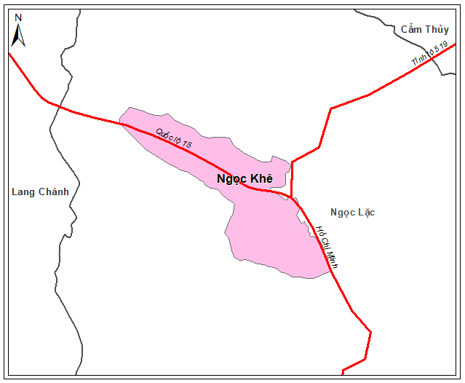 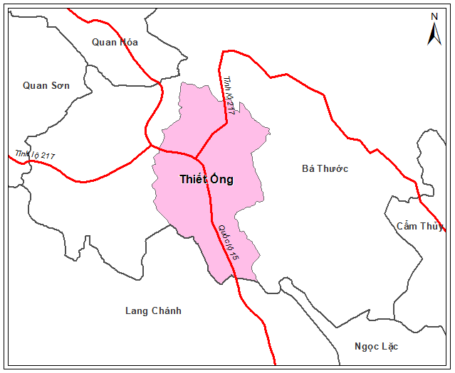

*Maps of Thiet Ong commune and Ngoc Khe with transportation roads*

Lack of secondary data on average income of peoply by commune makes futher analysis on energy type options not reliable.

***Estimation of fuelwood consumption per person per cluster***

The below table shows the estimation of fuelwood consumption for cooking purposes per person by cluster.

*Table. Average fuelwood consumption per person by cluster*

|  |  |  |
| --- | --- | --- |
| Cluster | Average fuelwood consumption per month  (kg/ person/ month) | Average fuelwood consumption per month (kg/ person/ year) |
| Cluster 6 | 41.0 | 492.0 |
| Cluster 5 | 42.3 | 507.6 |
| Cluster 4 | 39.5 | 474.0 |
| Cluster 3 | 21.2 | 254.4 |
| Cluster 2 | 8.3 | 99.6 |

The result shows that for cluster 6, 5, and 4, there is not much different in the average fuelwood consumption per month of around 40kg per person, while it is significantly reduced to 21kg per person per month for cluster 3, and 8kg per person per month for cluster 2.

In order to explain this, the below table show statistics data for forest, as source of fuelwood, by each cluster, per person.

Table 5. Characteristics of cluster

|  |  |  |  |  |  |  |  |
| --- | --- | --- | --- | --- | --- | --- | --- |
| **Cluster** | **Avg. area of natural forest (ha/person)** | **Avg. area of plantation forest (ha/person)** | **Avg. ratio of natural forest by commune (%)** | **Avg. ratio of plantation forest (%)** | **Avg. elevation (m)** | **Avg. annual temperature (C deg)** | **Avg. temperature of the coldest month (C Deg)** |
| 1 | 0.000 | 0.00 | 0.0 | 0.7 | 12.2 | 21.7 | 13.9 |
| 2 | 0.000 | 0.00 | 0.1 | 1.8 | 14.2 | 24.3 | 14.4 |
| 3 | 0.021 | 0.06 | 4.0 | 20.1 | 46.9 | 24.2 | 14.3 |
| 4 | 0.058 | 0.09 | 10.1 | 19.6 | 84.4 | 24.1 | 14.0 |
| 5 | 0.925 | 0.11 | 49.2 | 7.9 | 293.6 | 23.0 | 12.4 |
| 6 | 2.262 | 0.11 | 54.6 | 3.8 | 669.1 | 20.9 | 10.0 |

The above table shows that for cluster 6 and 5, the average area of forest per person, both natural and plantation, is significantly higher than that of cluster 3, while for cluster 2 there is almost no forest coverage on an average basis. It shows a clear trend that for the area that the forest coverage is still high, people still much rely on fuelwood as one of the major energy source.

Total fuelwood demand for households is estimated in the below table.

*Table – Total fuelwood demand by residential sector of Thanh Hoa and Nghe An*

|  |  |  |  |
| --- | --- | --- | --- |
| Geographic area | Population (person) | Fuelwood consumption per person per year (kg/ person/ year) | Total fuelwood consumption per year (ton/ year) |
| Thanh Hoa and Nghe An | 6,501,383 |  |  |
| Cluster 6 | 245,812 | 492.0 | 120,940 |
| Cluster 5 | 539,052 | 507.6 | 273,623 |
| Cluster 4 | 824,786 | 474.0 | 390,949 |
| Cluster 3 | 1,353,683 | 254.4 | 344,377 |
| Cluster 2 | 3,241,477 | 99.6 | 322,851 |
| Cluster 1 | 296,573 | - | - |
| TOTAL | | | **1,452,739** |

Sample for cluster 1 has not been surveyed during the field trip. Cluster 1 represent the most urbanized area of Thanh Hoa and Nghe An such as Thanh Hoa city and Vinh city. Total population of cluster 1 of Thanh Hoa and Nghe An is 296,573 persons. It is assumed that this group does not consume fuelwood as a basic energy for the daily cooking.

From the above table it is estimated that total fuelwood demand for household cooking is 1,453,739 ton per year.

#### Source of fuelwood consumed by residents

Calculation of percentage of fuelwood by the source is shown in table below.

|  |  |  |  |  |  |  |  |  |
| --- | --- | --- | --- | --- | --- | --- | --- | --- |
| **No** | **Province** | **District** | **Commune** | **Cluster** | **% of fuelwood from natural forest** | **% of fuelwood from plantation forest** | **% of fuelwood from home garden** | **% of fuelwood from other source** |
| 1 | Thanh Hóa | Bá Thước | Thiết Ống | 5 | 72 | 7 | 10 | 11 |
| 2 | Thanh Hóa | Bá Thước | Ban Công | 5 | 75 | 22 | 3 | 0 |
| 3 | Thanh Hóa | Lang Chánh | Giao An | 4 | 67 | 21 | 11 | 0 |
| 4 | Thanh Hóa | Lang Chánh | Trí Năng | 6 | 79 | 15 | 5 | 1 |
| 5 | Thanh Hóa | Ngọc Lặc | Minh Sơn | 4 | 44 | 44 | 12 | 0 |
| 6 | Thanh Hóa | Ngọc Lặc | Ngọc Khê | 4 | 55 | 43 | 3 | 0 |
| 7 | Thanh Hóa | Thường Xuân | Xuân Dương | 2 | 0 | 0 | 50 | 50 |
| 8 | Thanh Hóa | Thường Xuân | Xuân Cao | 3 | 1 | 34 | 0 | 64 |
| 9 | Nghệ An | Anh Sơn | Hùng Sơn | 3 | 12 | 71 | 14 | 4 |
| 10 | Nghệ An | Anh Sơn | Đức Sơn | 4 | 73 | 13 | 14 | 0 |
| 11 | Nghệ An | Tương Dương | Yên Tĩnh | 5 | 95 | 3 | 2 | 0 |
| 12 | Nghệ An | Tương Dương | Nga My | 5 | 92 | 5 | 3 | 0 |
| 13 | Nghệ An | Quế Phong | Châu Kim | 6 | 75 | 11 | 14 | 0 |
| 14 | Nghệ An | Quế Phong | Châu Thôn | 6 | 97 | 3 | 0 | 0 |

The numbers show that for the commune in cluster 4, 5, and 6, a majority of fuelwood used by household are exploited from natural forest.

For Xuan Cao commune of cluster 3, 64% of the fuelwood used are from other sources. It is because in Nam Cao village of Xuan Cao commune where the survey was conducted, 11 households out of 17 surveyed have supplement jobs of making taufu as the main income. Most of fuelwood consumed by these households are bought. They do not collect wood from natural, plantation forest or home garden.

For Xuan Duong commune of cluster 2, 50% of fuelwood used are from home garden and 50% are bought. As for cluster 2, there is almost no forest. People use much less fuelwood (average 8 kg per person per month), and utilize corn cob, acacia bark and branches to fulfill their biomass energy demand. Source fuelwood are from home garden, and from buying for which the original source cannot be identify.

The below picture show the typical biomass energy of Xuan Duong:

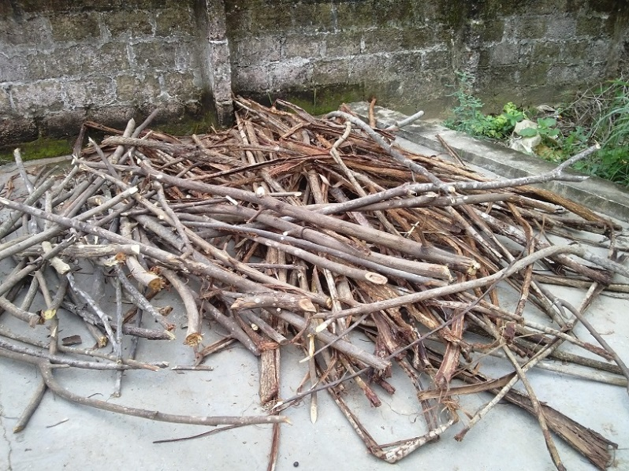

Figure 2. Acacia bark and Meliaceae branches from home garden

Collecting fuelwood from natural forest is not allowed. However it is happening frequently as this is of long-time tradition of Muong and Thai ethnic people. According to some forest rangers of the communes surveyed, it is very difficult to stop this tradition completely while residential fuel demand is obvious. Even for household that have electric rice cooker and LPG cooker, part of their fuel demand still rely on fuelwood and this trend will not reduce soon. However for other households that have not yet electric rice cooker and LPG cooker, they tend to buy these when their income increase. Therefore the demand for fuelwood for residents will tend to decrease gradually.

There is one remarkable case in Tuong Duong district of Nghe An where natural forest is rapidly lost because of shifting cultivation. According to the district officer, the upland farm is only recorded on the document, but there is no parcel map and no official land certificate for this type of land use. Each year every household will clear 1-2 ha of regrowth or poor forest to growth corn and rice. This process is repeated every year on the large scale is the largest thread in deforestation. Because the shifting cultivation farm is a land use category recognized by local government the people have the right to use this type of land for agriculture cultivation. Since there is no clear boundary and no parcel map, it is very difficult to apply punishment to households that encroaching into forest because the location and boundary of his land cannot be identified in the first place. This annual activity of shifting cultivation include the activity of burning forest. After the burning, there are plenty of good big size natural wood for the household to use as fuelwood. According to these household, the natural wood collected from burning forest give them plenty of fuelwood for their cooking. It is even exceed their demand.

The below picture was taken with Tuong Duong district officer, that show the lost of natural forest caused by shifting cultivation.

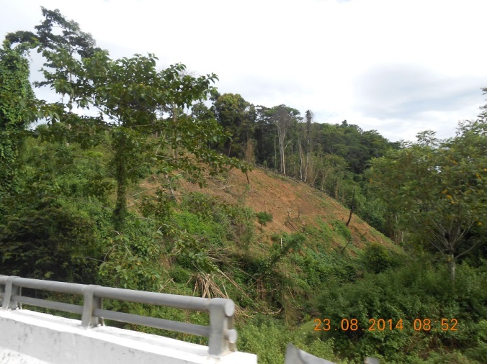

*Figure. Deforestation caused by shifting cultivation*

Calculation of percentage of fuelwood by source is shown in table below:

|  |  |  |  |  |
| --- | --- | --- | --- | --- |
| Cluster | % of fuelwood from natural forest | % of fuelwood from plantation forest | % of fuelwood from home garden | % of fuelwood from other source |
| Cluster 6 | 83 | 10 | 6 | 0 |
| Cluster 5 | 84 | 9 | 4 | 2 |
| Cluster 4 | 60 | 30 | 11 | 0 |
| Cluster 3 | 6 | 51 | 6 | 37 |
| Cluster 2 | 0 | 0 | 50 | 50 |

The result shows that in cluster 5 and 6, where there are more natural forest per person, it is clear that people most prefer to use natural forest. They explain that natural forest wood give better quality of fire, more thermal value. Fuelwood plantation forest such as acacia is less prefered because the fire from acacia create much smoke which is uncomfortable.

For cluster 3 and 4 where the average coverage of plantation forest per person is highest and coverage of natural forest is much lower, people tend to switch to utilize fuelwood from plantation forest which is left after harvesting, including branches and top of acacia, melia, chukrasia, and the lower part of bamboo trunks. For cluster 3, people also tend to use more fuelwood bought from the market.

For cluster 2 where there is not forest, people use fuelwood from their home garden and from purchasing from market.

The residential fuelwood consumption by source of fuelwood is as below:

*Table – Total residential fuelwood consumption by source*

|  |  |  |  |  |  |  |  |  |  |
| --- | --- | --- | --- | --- | --- | --- | --- | --- | --- |
| Cluster | Total fuelwood consumption (ton/ year) | % of fuelwood from natural forest | Quantity of fuelwood from natural forest (ton/ year) | % of fuelwood from plantation forest | Quantity of fuelwood from plantation forest (ton/ year) | % of fuelwood from home garden | Quantity of fuelwood from home garden forest (ton/ year) | % of fuelwood from other source | Quantity of fuelwood from other source (ton/ year) |
| Cluster 6 | 120,940 | 83 | 100,380 | 10 | 12,094 | 6 | 7,256 | 0 | 0 |
| Cluster 5 | 273,623 | 84 | 229,843 | 9 | 24,626 | 4 | 10,945 | 2 | 5,472 |
| Cluster 4 | 390,949 | 60 | 234,569 | 30 | 117,285 | 11 | 43,004 | 0 | 0 |
| Cluster 3 | 344,377 | 6 | 20,663 | 51 | 175,632 | 6 | 20,663 | 37 | 127,419 |
| Cluster 2 | 322,851 | 0 | 0 | 0 | 0 | 50 | 161,426 | 50 | 161,426 |
| **Total by source** | **1,453,740** |  | **585,456** |  | **329,637** |  | **243,294** |  | **294,317** |

The source of fuelwood from other sources is not identified during the survey because these woods are bought from the market and the consumer cannot tell the source of these wood. In the next session of this report it indicates that 100% of commercial wood are from natural market. Therefore it is assumed that the source of fuelwood from other sources are also from natural forest.

***Total residential fuelwood consumption of Thanh Hoa and Nghe An by source is as below:***

|  |
| --- |
| Total consumption: 1,453,740 ton per year, in which:   * From natural forest: 879,773 ton per year, equivalent to 61% * From plantation forest: 329,637 ton per year, equivalent to 23 % * From home garden: 243,294 ton per year, equivalent to 16% |

#### Size of fuelwood consumed by residents

While the source of fuelwood from natural forest/ plantation forest/ home garden/ or other sources is depending on the location (or cluster) of the household whether which source is more available, the preference of size of fuelwood consumed by household would not be much different between the household of different location (or cluster). This is because they all use stove for cooking, either traditional tripod stove or improved stove for which the most suitable size of fuelwood for stove is 5-15cm. The table below shows the size of fuelwood consumed by commune.

|  |  |  |  |  |  |  |  |
| --- | --- | --- | --- | --- | --- | --- | --- |
| **No** | **Province** | **District** | **Commune** | **Cluster** | **% of fuelwood size>15cm** | **% of fuelwood size 5-15cm** | **% of fuelwood of branches <5cm** |
| 1 | Thanh Hóa | Bá Thước | Thiết Ống | 5 | 0 | 13 | 87 |
| 2 | Thanh Hóa | Bá Thước | Ban Công | 5 | 0 | 19 | 81 |
| 3 | Thanh Hóa | Lang Chánh | Giao An | 4 | 2 | 25 | 73 |
| 4 | Thanh Hóa | Lang Chánh | Trí Năng | 6 | 3 | 11 | 86 |
| 5 | Thanh Hóa | Ngọc Lặc | Minh Sơn | 4 | 0 | 13 | 87 |
| 6 | Thanh Hóa | Ngọc Lặc | Ngọc Khê | 4 | 8 | 25 | 67 |
| 7 | Thanh Hóa | Thường Xuân | Xuân Dương | 2 | 0 | 15 | 85 |
| 8 | Thanh Hóa | Thường Xuân | Xuân Cao | 3 | 0 | 42 | 58 |
| 9 | Nghệ An | Anh Sơn | Hùng Sơn | 3 | 0 | 27 | 73 |
| 10 | Nghệ An | Anh Sơn | Đức Sơn | 4 | 0 | 19 | 81 |
| 11 | Nghệ An | Tương Dương | Yên Tĩnh | 5 | 40 | 50 | 10 |
| 12 | Nghệ An | Tương Dương | Nga My | 5 | 13 | 61 | 26 |
| 13 | Nghệ An | Quế Phong | Châu Kim | 6 | 4 | 59 | 37 |
| 14 | Nghệ An | Quế Phong | Châu Thôn | 6 | 3 | 20 | 77 |

The result shows that for residential use of fuelwood, people tend to use the fuelwood of size less than 15 cm. The ratio of fuelwood size bigger than 15cm is less than 10% for most of the communes surveyed. Only for Yen Tinh and Nga My commune of Tuong Duong district, people tend to use fuelwood of size larger than 15cm. This is because for Tuong Duong district, burning forest for shifting cultivation is happening in a vast area, that create a huge source of wood from natural forest, of which many trees are of larger size.

Below are pictures of fuelwood used at kitchen of households.

|  |  |
| --- | --- |
| E:\GFD\02 Ongoing projects\0193 SNV fuelwood baseline\Implementation\Field Trip\Anh\Anh report\CAM02691.jpg | E:\GFD\02 Ongoing projects\0193 SNV fuelwood baseline\Implementation\Field Trip\Anh\Anh report\CAM02661.jpg |
| E:\GFD\02 Ongoing projects\0193 SNV fuelwood baseline\Implementation\Field Trip\Anh\Anh report\CAM02680.jpg | E:\GFD\02 Ongoing projects\0193 SNV fuelwood baseline\Implementation\Field Trip\Anh\Anh report\CAM02717.jpg |

The below table show the ratio of fuelwood used by size by cluster:

|  |  |  |  |
| --- | --- | --- | --- |
| Cluster | % of fuelwood size>15cm | % of fuelwood size5-15cm | % of fuelwood of branches <5cm |
| Cluster 6 | 4 | 29 | 68 |
| Cluster 5 | 14 | 38 | 48 |
| Cluster 4 | 2 | 20 | 78 |
| Cluster 3 | 0 | 34 | 66 |
| Cluster 2 | 0 | 15 | 85 |

The result shows the size of fuelwood used for residential biomass demand, that most of fuelwood consumed for household are of the size of 15cm and less, in which the use of branches of size less than 5cm count up for approximately two third of the fuelwood consumption.

Only for cluster 5 the ratio of fuelwood of size larger than 15cm is higher than 10%. This number is influenced by the case of Tuong Duong district as discussed above.

At average, the ratio of fuelwood size >15cm consumed by household is 4%, the ratio of fuelwood size 5-15cm is 27%, and the ratio of fuelwood size <5cm is 69%.

#### Fuelwood for pig raising

The amount for cooking for one pig per month is very much different by age of the pig. For a pig at one month old, the fuelwood amount for cooking for one pig could be half of that for a person, while for a pig at 4 to 5 months old, it would be double of the fuelwood amount for cooking for one person.

In-depth interviews were conducted with two households that raise pigs to estimate the total wood consumption for one pig life cycle. It is estimated that in the upland area (Ba Thuoc, Lang Chanh, Que Phong, Tuong Duong district – cluster 5, 6) where pig only eat cooked feed, it needs about 200kg of wood for raising one pig in 5 months.

In lower land in Hung Son (cluster 3), Duc Son (cluster 4) commune of Anh Son district, half of pig feed is cooked by fuelwood and the other half is from commercial ready animal feed which does not require cooking. Therefore the consumption of wood per pig head at the low land is estimated at half of the upland for 100kg of fuelwood for a pig life cycle of 5 months.

For the households that raise less than 10 pig heads per year, the energy for cooking pig feed still rely mainly on fuelwood.

Amongst the 36 households surveyed that raise more than 10 pig heads per year:

* 11 households purchase fuelwood for an average of VND 500,000 per month for an average of 780kg of fuelwood per month. About half the fuelwood is used for pig feed cooking and the other half is used for supplement jobs.
* 3 household have biogas from pig manure that supply most energy need for pig feed cooking. Out of the 33 households that have yet biogas, 15 households have a plan to invest in biogas system extracted from pig manure. The cost for investing a biogas system is around 12 million VND. 4 households expect government support for biogas investment.

Therefore, there is a trend that the fuelwood consumption for pig raising will decrease at the household that raise pig at larger scale (more than 10 pig heads per year) because they tend to switch to biogas use.

***Estimation of fuelwood consumed for pig raising in Thanh Hoa and Nghe An***

The in-depth interviews about fuelwood for pig raising show that estimation of fuelwood for one pig raising for cluster 5, 6 is 200 kg per pig head, while for cluster 3, 4 it is about 100 kg per pig head. It is projected that for cluster 2, the fuelwood for one pig head is less, at 50 kg per pig head. Below is a conservation estimation of fuelwood for pig raising because it does not consider the reduction of fuelwood consumed at the household that use biogas.

*Estimation of total fuelwood consumed for pig raising in Thanh Hoa is as below:*

|  |  |  |
| --- | --- | --- |
| District | Number of pig head by 2013 (pig/ year)** | Quantity of fuelwood for pig raising (ton/ year) |
| Bá Thước district | 16,100 | 3,366 |
| Bim Son town | 2,500 | 277 |
| Cẩm Thủy district | 4,400 | 1,171 |
| Đông Sơn district | 43,100 | 1,599 |
| Hà Trung district | 16,700 | 1,157 |
| Hậu Lộc district | 36,200 | 3,042 |
| Hoằng Hóa district | 69,000 | 6,429 |
| Lang Chánh district | 56,200 | 2,063 |
| Mường Lát district | 23,500 | 2,680 |
| Nga Sơn district | 70,800 | 6,560 |
| Ngọc Lạc district | 56,000 | 1,702 |
| Như Thanh district | 29,100 | 589 |
| Như Xuân district | 70,000 | 890 |
| Nông Cống district | 32,000 | 2,689 |
| Quan Hóa district | 60,000 | 3,321 |
| Quan Sơn district | 26,400 | 2,589 |
| Quảng Xương district | 24,500 | 5,752 |
| Sầm Sơn town | 29,300 | 156 |
| Thạch Thành district | 34,200 | 986 |
| Thanh Hóa city | 14,200 | 1,773 |
| Thiệu Hóa district | 18,700 | 2,841 |
| Thọ Xuân district | 20,600 | 3,203 |
| Thường Xuân district | 32,600 | 2,835 |
| Tĩnh Gia district | 37,100 | 3,850 |
| Triệu Sơn district | 23,400 | 4,934 |
| Vĩnh Lộc district | 17,600 | 763 |
| Yên Định district | 13,400 | 4,430 |
| **Total** | **887,600** | **71,646** |

** Statistical Yearbook Thanh Hoa 2013

*Estimation of total fuelwood consumed for pig raising in Nghe An is as below:*

|  |  |  |
| --- | --- | --- |
| District | Number of pig head by 2013 (pig/ year)** | Quantity of fuelwood for pig raising (ton/ year) |
| Anh Sơn | 52,431 | 6,934 |
| Con Cuông | 29,961 | 5,847 |
| Cửa Lò town | 2,469 | 160 |
| Diễn Châu | 79,084 | 5,761 |
| Đô Lương | 105,809 | 9,385 |
| Hưng Nguyên | 24,219 | 1,442 |
| Kỳ Sơn | 30,720 | 6,141 |
| Nam Đàn | 37,302 | 3,117 |
| Nghi Lộc | 58,207 | 4,677 |
| Nghĩa Đàn | 37,073 | 4,098 |
| Quế Phong | 28,504 | 5,697 |
| Quỳ Châu | 23,090 | 4,615 |
| Quỳ Hợp | 51,502 | 8,524 |
| Quỳnh Lưu | 116,967 | 9,919 |
| Tân Kỳ | 46,096 | 5,682 |
| Thái Ḥòa town | 11,472 | 1,042 |
| Thanh Chương | 110,349 | 16,438 |
| Tương Dương | 28,908 | 5,779 |
| Vinh | 13,219 | 494 |
| Yên Thành | 127,548 | 11,045 |
| **Total** | **1,014,930** | **116,796** |

** Statistical Yearbook Nghe An 2013

Total fuelwood for pig raising for Thanh Hoa and Nghe An is estimated at 188,442 ton per year.

|  |
| --- |
| Total fuelwood for pig raising for Thanh Hoa and Nghe An: 188,442 ton per year   * For Thanh Hoa: 71,646 ton per year * For Nghe An: 116,796 ton per year |

#### Fuelwood for supplement jobs

Out of 221 households surveyed, 32 households have supplement jobs that use fuelwood. Amongst these 32 households with supplement jobs:

* Average fuelwood consumption of each of the households is 580 kg per month, most of that are used for the supplement jobs.
* 13 households purchase fuelwood for an average of 460,000 VND per month.
* 14 households only use traditional tripod cookers for cooking; 18 households are using improved stoves.
* All households that are using traditional tripod cookers for cooking are interested in improved stoves to save fuelwood.

There are not sufficient data to estimate the total outputs of the supplement jobs by the household hence it is not allowed to estimate a quantitative amount of fuelwood consumed for supplement jobs.

### Industrial and commercial fuelwood demand

#### Fuelwood supply chain

Investigation of fuelwood trading activities are conducted in Lang Chanh district of Thanh Hoa province and Quy Hop district of Nghe An province where fuelwood trading are most active. These two districts are located at the intersections of major transportation roads that leads to different part of the provinces hence are convenient for fuelwood trading.

Fuelwood supply chain in Thanh Hoa and Nghe An is a simple chain that involves the following people, organizations and activities.

|  |  |
| --- | --- |
| People/ Organization | Activities |
| Farmer | * Logging wood from forest and deliver at truck road at villages |
| Wood collector | * Collect wood from the sites that farmers deliver by farm vehicle * Upload wood to trucks |
| Middleman | * Arrange transportation documents from commune office * Negotiate fuelwood selling with the plants |
| Transporter | * Deliver wood to industrial plant by truck |
| Industrial plants | * Purchasing wood from middleman |

In this supply chain, the middleman is the most important actor that arrange the chain of activities, as he connect with major actors in the chain, including wood collector, transporter, and industrial plant procurer.

The average distance of transportation is around 50km. Normally this distance is within a district that allow the wood to be transported with the verification of wood from commune levels. Wood to be transported out of the district and province will require verification of wood from district rangers. Investigation of the two middlemen in this field trip shows that for both cases the fuelwood are either illegally exploited, or exploited at a grey are where it is hard to determine whether the fuelwood are legally or illegally expoited. The fuelwood cannot get the verification of district rangers and cannot be transported beyond the boundary of the districts. This issue will be further discussed in the next part of ‘Source of fuelwood for local industrial demand’.

As the commercial wood investigated in these two cases is all consumed within the distance of 50km, it is assumed that the all commercial wood traded in these two provinces are consumed locally for local industrial demand. Therefore the analysis below is for both commercial and local industrial demand of fuelwood.

#### Quantity of fuelwood for industrial demand

In order to quantitatively estimate local industrial demand for fuelwood, data for total capacity by each industrial sector by district is needed. Each industrial sector such as paper mill, tea processing, MDF manufacturing, alcohol and beverage, food processing has a typical production procedure and a typical indicator for fuel consumption per product unit which can be use as a reference. Therefore data for total capacity by industrial sector is needed to estimate the total fuel demand.

In the other hand, fuelwood exploited in Thanh Hoa and Nghe An are supplied to industrial plants within a distance of 50km. Therefore, it needs to identify the locations of the plants to project the potential fuelwood demand. Hence the capacity of industrial sector by district is required for a quantitative analysis.

Since there is not data on local industrial plants available with specific information on production capacity, a quantitative estimation of fuelwood demand for the local plants cannot be done with reliability.

As having explained above, it is assumed that all commercial fuelwood exploited in Thanh Hoa and Nghe An are supplied to local industrial plants. Therefore an analysis of quantity of commercial fuelwood would give an understanding of quantity of local industrial fuelwood consumption. Below are analysis of quantity of commercial wood of the two locations investigated.

***Quantity of commercial fuelwood in Lang Chanh district, Thanh Hoa***

There are three middlemen trading fuelwood in Lang Chanh district and selling to local plants. One of the three is invested. He is selling about 5 tons of fuelwood per day to two plants: one paper mill in Lang Chanh district for 2.5 ton per day and one bamboo chop plant in Quan Hoa district of Thanh Hoa for 2.5 ton per day. The paper mill in Lang Chanh that he mentioned was investigated that it verifies the information that he provides. So it is assumed that other information he provides is true.

According to the middlemen investigated, the total daily trading amount of all the three middlemen in Lang Chanh is about 14-15 tons per day, all are consumed as fuelwood, for about 300 days a year. It is estimated that the demand for fuelwood for commercial purpose at Lang Chang is 4,500 tons/year.

Lang Chanh is a district of Thanh Hoa province, which has a population of 43,913 person. Natural area is of 5,846 km2. Population density of 7.51 person per square kilometer. This population density is low compared to average density of Thanh Hoa province of 32.1 person per square kilometer.

Lang Chanh has average natural forest per capita of 0.67 hectare/ person and plantation forest per capita of 0.28 hectare/ person (compared to 0.11 and 0.03 of Thanh Hoa province).

Table 6. Demography of Lang Chanh district, Thanh Hoa

|  |  |  |  |  |  |  |  |
| --- | --- | --- | --- | --- | --- | --- | --- |
|  | Population | Area (ha) | Density person/km2 | Natural forest area (ha) | Plantation forest area (ha) | Area of natural forest per pax | Area of plantation forest per pax |
| Thanh Hoa | 3,557,482 | 1,108,239 | 32.10 | 381,220 | 110,968 | 0.11 | 0.03 |
| Lang Chanh  District | 43,913 | 58,463 | 7.51 | 29,347 | 12,151 | 0.67 | 0.28 |

Lang Chanh district include 3 clusters of 4, 5, and 6. Residential fuelwood consumption of Lang Chanh is estimated in the table below.

|  |  |  |  |  |  |  |  |  |  |  |  |
| --- | --- | --- | --- | --- | --- | --- | --- | --- | --- | --- | --- |
| Area | Population | Fuelwood consumption per person per year (kg/ person/ year) | Total fuelwood consumption per year (ton/ year) | % of fuelwood from natural forest | Quantity of fuelwood from natural forest (ton/year) | % of fuelwood from plantation forest | Quantity of fuelwood from plantation forest (ton/year) | % of fuelwood from home garden | Quantity of fuelwood from home garden (ton/year) | % of fuelwood from other source | Quantity of fuelwood from other sources (ton/year) |
| Lang Chanh district | 43,913 |  | 21,346 |  | 15,485 |  | 4,071 |  | 1,699 |  | 75 |
| Cluster 6 of Lang Chanh | 15,666 | 492.0 | 7,708 | 83 | 6,397 | 10 | 771 | 6 | 462 | 0 | 0 |
| Cluster 5 of Lang Chanh | 7,423 | 507.6 | 3,768 | 84 | 3,165 | 9 | 339 | 4 | 151 | 2 | 75 |
| Cluster 4 of Lang Chanh | 20,824 | 474.0 | 9,870 | 60 | 5,922 | 30 | 2,961 | 11 | 1,086 | 0 | 0 |

The consumption of fuelwood by sector in Lang Chanh is as below:

|  |  |  |  |
| --- | --- | --- | --- |
| Quantity of fuelwood by source | Unit | Residential consumption | Commercial consumption |
| Natural forest | Ton/ year | 15,485 | 4,500 |
| Plantation forest | Ton/ year | 4,071 | 0 |
| Home garden | Ton/ year | 1,699 | 0 |
| Other sources | Ton/ year | 75 | 0 |

The quantity of fuelwood from natural forest for residential demand is more than three times of the commercial demand. However, the quality of the fuelwood from natural forest consumed by each sector is represented at the table below.

|  |  |  |  |  |
| --- | --- | --- | --- | --- |
| Natural fuelwood by size | Residential consumption by %* | Residential consumption in quantity (ton/ year) | Commercial consumption by % | Commercial consumption in quantity (ton/ year) |
| Total fuelwood from natural forest | 100 | 15,485 | 100 | 4,500 |
| Size > 15cm | 7 | 1,084 | 85 | 3,825 |
| Size 5-15cm | 29 | 4,491 | 15 | 574 |
| Size < 5cm, branches | 64 | 9,910 | 0 | 0 |

* Average of cluster 6, 5, and 4

The data shows that for the larger fuelwood from natural forest of size 15cm and above, about 80% is consumed for commercial demand and 20% is consumed for residential demand (3,825 ton/ year and 1,084 ton/year respectively).

***Quantity of commercial fuelwood in Nam Son commune, Quy Hop district, Nghe An***

There is only one middleman who trades wood in Nam Son commune. On average he sells about 7 tons of wood per day to a MDF plant in Nhu Xuan district of Thanh Hoa. An investigation was conducted at the MDF plant that he mentioned. It was found out that the MDF plant is purchasing about 200 tons of wood per day, in which 90% is used as material for MDF, and 10% is used as fuelwood for the plant’s boiler.

Applying this ratio to the middleman in Nam Son who supplies wood to the MDF plant, it is assumed that 10% of his wood is consumed as fuelwood. An estimation of commercial fuelwood demand at Nam Son commune is 210 tons per year (for 300 days of operation per year).

Nam Son is a commune of Quy Hop district which belong to cluster 5. Nam Son commune has a very high average area of natural forest per person which is of ten times of that of Quy Hop in particular and of Nghe An in general. Below table show demography data of Nam Son commune, Quy Hop district, and Nghe An province.

Table 7. Demography of Nghe An province, Quy Hop district, Nam Son commune

|  |  |  |  |  |  |  |  |
| --- | --- | --- | --- | --- | --- | --- | --- |
|  | Population | Area (ha) | Density person/km2 | Natural forest area (ha) | Plantation forest area (ha) | Area of natural forest per person | Area of plantation forest per person |
| Nghe An province | 2,943,901 | 1,651,378 | 17.83 | 656,341 | 105,691 | 0.22 | 0.04 |
| Quy Hop district | 119,960 | 93,934 | 12.77 | 28,278 | 5,836 | 0.24 | 0.05 |
| Nam Son commune | 1633 | 6,377 | 0.39 | 3,754 | 52 | 2.3 | 0.03 |

Estimation of residential fuelwood consumption for Nam Son commune is as below.

|  |  |  |  |  |  |  |  |  |  |  |  |
| --- | --- | --- | --- | --- | --- | --- | --- | --- | --- | --- | --- |
| Area | Population | Fuelwood consumption per person per year (kg/ person/ year) | Total fuelwood consumption per year (ton/ year) | % of fuelwood from natural forest | Quantity of fuelwood from natural forest (ton/year) | % of fuelwood from plantation forest | Quantity of fuelwood from plantation forest (ton/year) | % of fuelwood from home garden | Quantity of fuelwood from home garden (ton/year) | % of fuelwood from other source | Quantity of fuelwood from other sources (ton/year) |
| Nam Son commune (cluster 5) | 1,633 | 507.6 | 829 | 84 | 696 | 9 | 75 | 4 | 33 | 2 | 17 |

The consumption of fuelwood by sector in Nam Son commune is as below:

|  |  |  |  |
| --- | --- | --- | --- |
| Quantity of fuelwood by source | Unit | Residential consumption | Commercial consumption |
| Natural forest | Ton/ year | 696 | 210 |
| Plantation forest | Ton/ year | 75 | 0 |
| Home garden | Ton/ year | 33 | 0 |
| Other sources | Ton/ year | 17 | 0 |

The quantity of fuelwood from natural forest for residential demand is more than three times of the commercial demand: 696 ton per year for residential consumption compared to 210 ton per year for commercial consumption. The quality of the fuelwood from natural forest consumed by each sector is shown at the table below.

|  |  |  |  |  |
| --- | --- | --- | --- | --- |
| Natural fuelwood by size | Residential consumption by % (cluster 5) | Residential consumption in quantity (ton/ year) | Commercial consumption by % | Commercial consumption in quantity (ton/ year) |
| Total fuelwood from natural forest | 100 | 696 | 100 | 210 |
| Size > 15cm | 14 | 97 | 85 | 179 |
| Size 5-15cm | 38 | 264 | 15 | 31 |
| Size < 5cm, branches | 48 | 334 | 0 | 0 |

The annual quantity of natural forest fuelwood of the size of 15cm and above is 97 ton for residential demand, and 179 ton for commercial demand. In ratio, the commercial demand count for about 60% of total larger fuelwood exploited from natural forest.

#### Source of fuelwood for industrial demand

Data from the middlemen interviewed shows that 100% of fuelwood are from natural forest. It was also observed that 100% of fuelwood for commercial activities and consumed at local industrial plants are natural wood. Picture below shows the fuelwood at the plants.

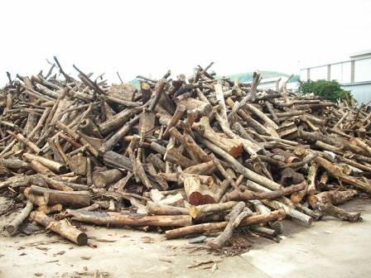 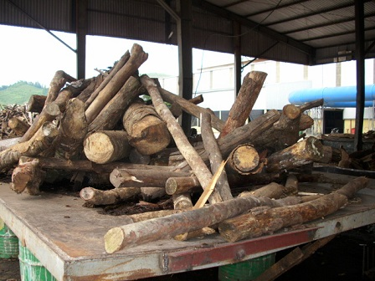

It is obvious that these wood are not Bamboo or Acacia, which are major trees of plantation forest in Thanh Hoa and Nghe An.

The reason that only natural forest fuelwood are used as fuelwood at the industrial plant is that the price of planted wood (Acacia) to sell as paper material is higher than natural wood. The price of Acacia at collection site at district (without transportation cost) is 750,000 – 850,000 VND per fresh ton after peeling the bark (right after cutting down, most of moisture is still contained), while the price of natural wood at collection site at district is from 500,000 to 550,000 VND per ton for partly dry wood (2-3 weeks after cutting down).

The natural forest fuelwood price is lower than the price for material wood because these natural wood are either in curved shape or of the species which are not prefered for furniture manufacturing. In other words, these natural wood cannot be sold as material wood to produce furniture. Therefore the price of fuelwood is lower than the price of Acacia.

For the case of the middleman in Lang Chanh district of Thanh Hoa, the man admits that 100% of his wood are exploited illegally. He has to arrange transportation without verification or permission papers.

However, for the case of the middleman in Nam Son commune, Quy Hop district of Nghe An, the middleman said that the fuelwood are exploited from the natural forest which are being converted into plantation forest. So he supposes that the wood are legally exploited. He can get the verification document from commune officer. However, when being asked if he can transport the wood to other provinces, he says that it is not possible because he cannot get the verification document from district ranger.

Since Quy Hop district is not in the list of the districts that VFD office arranges working session with local government officers, the investigator cannot meet with officers of Nam Son commune and Quy Hop district to verify the information about forest conversion and whether such exploitation of forest wood are legal or not. However, it is remarked that there is a grey area in legality of fuelwood and other natural wood being exploited in Nam Son commune, Quy Hop district, Nghe An province.

The below picture shows the plantation forest of Acacia was converted from natural forest. On the area that Acacia is planted, all natural trees were logged. In the next area, natural forest with natural trees still exist.

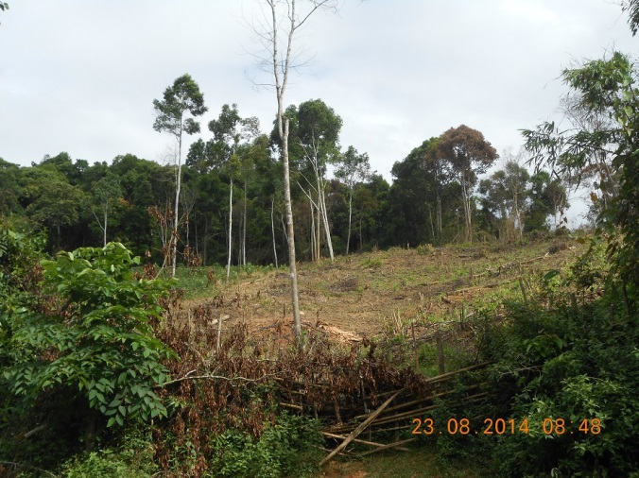

#### Size of fuelwood consumed by local industrial plants

The size of the fuelwood of commercial demand is as below:

* For the middleman in Nam Son commune, Quy Hop district, Nghe An province: 60-70% of size 25cm and above, and the rest 30-40% is of size 15-25cm.
* For the middleman in Lang Chanh district, Thanh Hoa province: 20-30% of size 10-15cm, 50-60% of size 15-25cm, and 10% of size 25 cm and above.

For industrial consumption of fuelwood, the size of less than 10cm is not suitable for operation. The prefered size is from 15cm and above. The pictures below show the fuelwood at the plants.

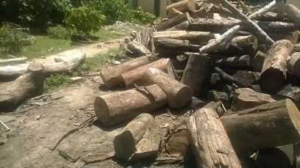 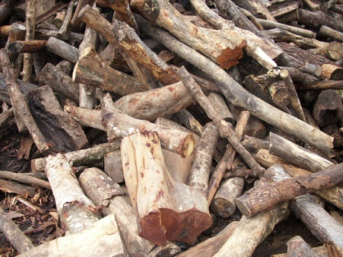

Based on the two cases investigated, it is estimated that fuelwood consumed by industrial plants include 15% of size 10-15cm, 50% of size 15-25cm, 35% of size 25cm and above.

#### Price of fuelwood that impacts the industrial plants’ choice for fuel

Investigation of middlemen and industrial plants show that fuelwood delivered at the plants are sold at the price of 600,000 to 650,000 VND per ton. The average moisture of the fuelwood is estimated at 35% as it is partly dried since logged.

The below table show the total calorific value of wood at oven dry condition.

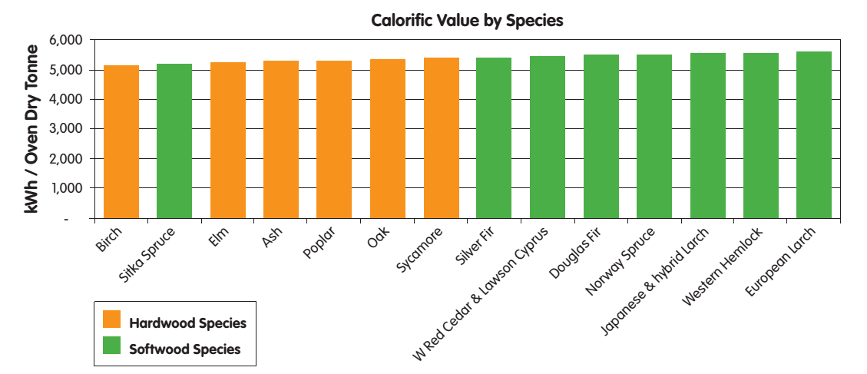

*Source: Wood as Fuel, Biomas Energy Center, 2010*

Based on above information, it is assumed that at oven dry condition, the fuelwood sold to local industrial plants has calorific value of 5,000 kWh per ton.

1 kWh = 860 kcal. Therefore it is assumed that a ton of fuelwood at oven dry condition has 4,300,000 kcal of total calorific value. It means the total calorific value of fuelwood at oven dry condition is 4,300 kcal/kg.

The fuelwood is sold at local industrial plants at the price of 650,000 VND per ton of moisture of 35%. It means the actual price of fuelwood per calorific value is 0.23 VND/ kcal.

Dust coal of total calorific value of 5,600 kcal/kg (TCVN 200:1995) at the actual moisture of 8% are sold in Thanh Hoa and Nghe An for the price of 1,950 VND per kg. It means the actual price of dust coal per calorific value is 0.38 VND/ kcal.

Coal of total calorific value of 7,500 kcal/kg (TCVN 200:1995) at the actual moisture of 8% are sold in Thanh Hoa and Nghe An for the price of 3,800 VND per kg. It means the actual price of dust coal per calorific value is 0.55 VND/ kcal.

It is obvious that the price per calorific value of fuelwood in Thanh Hoa and Nghe An is much cheaper than that of coal and dust coal. At the selling price of 600,000 – 650,000 VND per ton of fuelwood at the moment, industrial plants that locate at the distance of 50km from forest wood source certainly tends to switch to fuelwood rather than using coal and dust coal.

This has happened at a tea plant survey in Thanh Chuong district, with total installed capacity of this plant is 25 tons of fresh tea per day. Three years ago they used dust coal fired furnace to dry the tea. But since 2011 they switched to wood firing because it helped saving up to 30-35% of the cost. The wood they bought are from Laos and Ha Tinh province because the distance of transport from Laos and Ha Tinh are closer than from other area of Nghe An (within 50km).

On the contrary, a paper mill in Hung Nguyen district in the delta area of Nghe An province choose to use coal for their boilers instead of fuelwood. The director of the plant says that he tried to use fuelwood before but it is not competitive in terms of costs.

#### Total fuelwood demand for commercial and local industries

An estimation for fuelwood demand for local industries requires the data of total production capacity by industrial sector by district.

Data for total capacity by industrial sector is to estimate the total thermal energy demand by each sector.

Data for total capacity by industrial sector by district is to project the total capacity of the plants that locate near forest within the distance of 50km that tend to switch to fuelwood instead of coal and dust coal.

Since there are not sufficient secondary data for analysis, any projection on the industrial demand would be unreliable.

### Total fuelwood demand in Thanh Hoa and Nghe An

Total fuelwood demand in Thanh Hoa and Nghe An include:

* Fuelwood demand for residential
* Fuelwood demand for commercial and local industries
* Fuelwood demand for pig raising
* Fuelwood demand for supplement jobs

Fuelwood demand for households, pig raising, and local industries have been discussed above, in which estimation for local industries are not available. There is not statistics available for household supplement jobs in Thanh Hoa and Nghe An. Therefore these two sectors are not included in the conclusion of this report.

An estimation of total fuelwood demand for Thanh Hoa and Nghe An including residents and pig raising is **1,641,182** ton per year in which 1,452,740 ton is for households’ meals cooking and 188,442 ton is for pig raising.

It is assumed that the ratio by source of fuelwood for pig rasing is not different from that for household cooking. The ratios are 61% from natural forest, 23% from plantation forest, and 16% from home garden. In definite amount, the households demand for fuelwood annually are 1,001,121 ton from natural forest, 377,472 ton from plantation forest, and 262,589 tons from home garden.

The fuelwood demand for households by wood size are 4% for size >15cm, 27% for size 5-15cm, and 69% for size <5cm.

## Sustainable fuelwood supply

### Estimation of fuelwood production by forest type

From forest management view point, there could be an optimal amount of fuelwood removed from forest, in term of dead wood and litter fall, without too much effect on the ecological condition of the forest. Some silviculture measure, for example forest enrichment, often include the practice of removing some bushes, lianas and pioneer trees to give space for more valuable species or to plant new valuable species. This type of activities could yield certain amount of fuelwood to be collected sustainably.

To estimate the fuelwood production of Thanh Hoa and Nghe An a literature reviewed was conducted and the value of forest with similar condition is transferred to be used in fuelwood supply estimation. The review is based on two set of information: i) the natural production of litter fall which could partly be collected and use without much damage on the forest; ii) fuelwood production from other countries with forest condition similar to Vietnam. When the range of value from literature is wide, the principle is to be conservative and use the lower range of the value.

Table 8. Litter fall production of different forest type

|  |  |  |  |  |
| --- | --- | --- | --- | --- |
| **Forest type** | **Country** | **Litter fall production (tons/ha/year)** | **Branch proportion %** | **Source** |
| Broad leaf forest | New Zealand | 6.1 |  | M.J. Daniel 1975[2] |
| Tropical broad leaf forest | Southern Brazil | 6.8 |  | S.M. Bergamini, et al 2009[3] |
| Broad leaf forest | Fujian, China | 11 | 11-26 | Y.S. Yang et all 2003[4] |
| Broad leaf forest | Vinh Phuc, Vietnam | 5.9-8.1 | 20-43 | D.T. Le 2009[5] |
| Pine forest | North East Vietnam | 6.2 | 43 | T.T. Dang 2009 |

Litter production and the proportion of branch from several studies is presented Table 8. The litter production is in the range of 5.9-11 tons/ha/year and the branch proportion is between 11% to 43 %. The lower range of studies in Vietnam is selected to use that give:

Annual branch (in litter fall) production = 5.9 tons/ha x 20% = 1.18 tons/ha

Assume that 20% of the branch production could potentially be collected and used as fuelwood, it give:

Annual collectable branch production = 1.18*20% = 0.236 tons/ha/yeas.

In addition to litter fall, fuelwood can also be extracted from forest by mean of residue, small round wood (SRW) and thinning. Several study about fuelwood production of forest in Finland, India and UK is presented in Table 9.

Table 9. Fuelwood production from 4 different forest type

|  |  |  |
| --- | --- | --- |
| **Fuelwood production** | **Forest type and location** | **Source** |
| 26 m3/ha/year | Conifer forest, Finland | Silva Fennica 44(2) research articles. The Finnish Society of Forest Science · The Finnish Forest Research Institute |
| 2.2 m3/ha/year | Deciduous forest, India | Food & Agriculture Org., Jan 1, 1989 - Arid regions forestry |
| 23 m3/ha (total fuelwood at time of measurement) | Homestead forest, South India | Agroforestry Systems, March 1994, Volume 25, Issue 3, pp 243-262 |
| 2.9 m3/ha/year | Temperate forest, UK | UK BIOMASS Energy Centre |

Since there is no study conducted for Vietnam, the value of fuelwood production of 2.2m3/ha/year for forest in India is selected to be transferred to use in this study. To be more conservative it have been decided to reduce this value by 20% that make the fuelwood production of 1.76tons/ha/year.

Together with the collectable branches mentioned earlier, the total collectable fuelwood production used for this study is: 1.76 + 0.236 = 1.996 tons/ha/year. In order to make a more realistic estimation, the fuelwood production is adjusted by forest type and forest standing stock. It is anticipated that a forest with higher standing stock would be able to produce more fuelwood but the relationship is not linear. Therefore the standing volume is used as a reference but the adjusted weight is assigned by expert knowledge. For plantation forest fuelwood is estimated as 10% of the mean annual increment with the assumption of 8 year rotation.

Table 10. Adjusted fuelwood production of different forest type. Average standing volume is based on FIPI data[6]

|  |  |  |  |  |
| --- | --- | --- | --- | --- |
| **Forest** | **Standing volume** | **Fuelwood production** | **Adjusted weight** | **Adjusted fuelwood production** |
| **Broad leaf rich** | 280 | 1.996 | 1.00 | 1.996 |
| **Broad leaf medium** | 163 | 1.996 | 0.80 | 1.597 |
| **Broad leaf poor** | 80 | 1.996 | 0.70 | 1.397 |
| **Broad leaf regrowth** | 50 | 1.996 | 0.50 | 0.998 |
| **Mixed woody bamboo** | 98 | 1.996 | 0.60 | 1.198 |
| **Bamboo** | 21 | 1.1 m3/year | | 1.1 |
| **Rock mountain forest** | 80 | 1.996 | 0.20 | 0.399 |
| **Plantation** | 90 | 10% of MAI – 8 year rotation | | 1.125 |

The total fuelwood supply of Nghe An and Thanh Hoa is estimated using parameter from Table 10 and forest area extracted from forest map of Thanh Hoa and Nghe An 2010.

### Fuelwood supply estimation for Thanh Hoa and Nghe An

The total fuelwood supply of two province is 1,905,039 tons/ha/year, of which Nghe An supply 1,193,421 tons/year and Thanh Hoa supply 711,617 tons/year. In Nghe An the forest type that provide the most fuelwood are: broad leaf re-growth forest (23.6%), broad leaf poor forest (22.8%) and broad leaf medium forest (15%); together these 3 type of forest accounted for 61.4% of the fuelwood supply of Nghe An. In Thanh Hoa the supply pattern is a bit different with the most important source of fuelwood supply being plantation forest (26.3%), broad leaf regrowth forest (17.3%) and bamboo (14.5%). This is necessary to note that this estimation should be considered as the potential availability of the fuel biomass, this do not include factors that influence the consumption and exploitation behaviour. For example the distance and accessibility to the source would have significant effect on fuelwood exploitation. The type of fuelwood also play important role in consumption’s choice, as mentioned earlier in the fuelwood demand (Section 3.1), where it is prevailing that people prefer natural fuelwood over plantation fuelwood. Thus in Thanh Hoa where plantation forest, mainly Acacia, provide as much as 26% of the total potential fuelwood, the consumption from this source could be much smaller. Also the fuelwood consumption at residential is collected local level, because it is not economically profitable to transport small size fuelwood from one place to other. Therefore the abundant of fuelwood at provincial level do not guaranty the sufficient at local level.

Table 11. Annual fuelwood supply in Thanh Hoa and Nghe An by forest type (Unit: tons/year)

|  |  |  |  |  |
| --- | --- | --- | --- | --- |
| Forest type | Nghe An supply (tons) | Thanh Hoa supply (tons) | Nghe An supply | Thanh Hoa supply % |
| Broad leaf rich | 118,863 | 20,082 | 10.0 | 2.8 |
| Broad leaf medium | 178,483 | 64,256 | 15.0 | 9.0 |
| Broad leaf poor | 271,898 | 98,574 | 22.8 | 13.9 |
| Broad leaf re-growth | 281,819 | 123,161 | 23.6 | 17.3 |
| Mixed woody bamboo | 63,487 | 83,325 | 5.3 | 11.7 |
| Rock mountain forest | 430 | 31,467 | 0.0 | 4.4 |
| Bamboo | 100,081 | 103,488 | 8.4 | 14.5 |
| Plantation | 178,360 | 187,263 | 14.9 | 26.3 |
| **Total** | **1,193,421** | **711,617** | **100.0** | **100.0** |

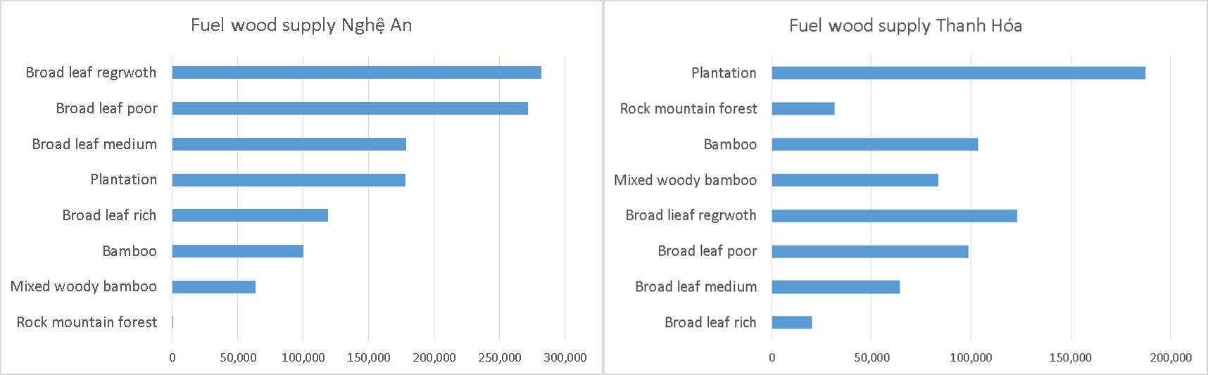

Figure 3. Fuelwood supply by forest type in Nghe An and Thanh Hoa

Looking at the geographic distribution of the supply source Figure 4 there is a clear trend that increase from delta to forest with cluster 6 and 5 dominant in fuelwood supply, cluster 4 and 5 is somewhat sufficient while cluster 2 and 1 provide almost no fuelwood. This trend is clearly reflect the pattern of fuelwood consumption, as presented in section 3.1, that cluster 6 and 5 rely heavily on fuelwood, while cluster 3 and 4 have to use additional source such as agriculture residue, electricity and gas, while cluster 1 and 2 is almost rely on alternative fuel. Detail data on fuelwood supply by district is attached in the appendix 2.

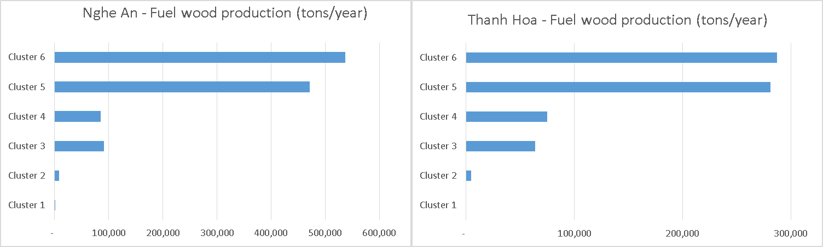

Figure 4. Fuelwood supply by cluster

## Key factors driving forest degradation

In summary, the fuelwood demand of households is **1,641,182** ton per year in which:

* 1,001,121 ton from natural forest
* 377,472 ton from plantation forest
* 262,589 tons from home garden.

The fuelwood demand for households by wood size are:

* 4% for size >15cm
* 27% for size 5-15cm
* 69% for size <5cm.

The total sustainable supply of fuelwood of dead trees, small trees and branches is calculated at **1,905,038** ton per year for the two provinces including:

* 1,157,136 ton per year from natural broad leaf forest
* 146,812 ton per year from mixed woody bamboo
* 31,897 ton per year from rock mountain forest
* 203,569 ton per year from bamboo forest
* 365,623 ton per year from Acacia plantation forest

This sustainable supply can fulfill the major fuelwood demand for household of which 96% of somewhat 1 million from natural forest is fuelwood of size less than 5cm.

Given the population growth rate of Thanh Hoa for the year of 2013 is 1.16% and that of Nghe An is 0.68%, this growth rate does not create significant pressures on the supply, while the trend for fuel switch from wood to electricity and LPG is happening continuously.

Quantitative estimation for local industries’ fuelwood demand is not available for further analysis. However, qualitative assessment of commercial fuelwood demand and industrial fuelwood consumption shows that the 100% fuelwood consumed by industrial sector is exploited from natural forest, in which 85% are of the size more than 15cm. At the two locations investigated, comparing the fuelwood demand of residential and industrial sectors for wood size more than 15cm shows that the industrial demand is about three to four time of residential demand.

In addition, larger size of wood from natural forest are also exploited and supplied as material wood at MDF and furniture manufacturers. Therefore it requires further investigation of local industrial demand for wood of both fuelwood and material wood to identify key factors that driving forest degradation.

## Value chain of fuelwood

Charcoal is not popularly used in the area of research. In fact, among 221 households surveyed and 7 plants using fuel visited, none of those use charcoal as a source of fuel. Therefore charcoal is not included in the survey and in the value chain assessment.

***Value chain of fuelwood in residential sector***

Amongst 221 household survey, only one household Hung Son commune, Anh Son district of Nghe An that sell fuelwood to a tea plant located in the same commune. The fuelwood that they sell are from the top and branches of Acacia plantation forest which is left after harvesting the Acacia trunk for paper material. Every year this household sells a total of 6 – 7 million VND of this biomass energy to the tea plant.

Out of this case, no other household surveyed sells fuelwood. Therefore it is concluded that there is no value chain of fuelwood in residential sector in Thanh Hoa and Nghe An.

***Value chain of fuelwood in commercial and industrial sector***

The below chart represent the value chain of fuelwood in Thanh Hoa and Nghe An

|  |  |  |  |  |
| --- | --- | --- | --- | --- |
| **Actor** | **Activity** | **Location** | **Income (VND/ ton)** | **Value (VND/ ton)** |
| Farmer/ Wood logger | Logging wood | Natural forest near truck road | 140,000 | 140,000 |
| Wood collector | Carry and upload wood to truck | Collection site (truck road) | 150,000 | 290,000 |
| Middleman | Prepare transportation license, letter of origin | Commune office | 180,000 | 470,000 |
| Transporter | Transport | Distance 50 km | 180,000 | 650,000 |
| Industrial Plant | Consumption | At plant |  |  |

The value chain of fuelwood is a chain of activities as below:

* **Logging:** The farmers are ordered by the wood collector to log wood from the forest for a wage of 140,000 VND per ton.
* **Loading:** The wood collector upload the wood on a farm vehicle and carry to a truck road, where the truck is waiting. He then upload the wood on the truck and sell them to the middleman for 290,000 VND per ton.
* **Preparing legal document:** The middleman is responsible for preparing transport documents for the wood and get verified by the commune rangers. Then the middleman hire a transporter to sell the wood to the industrial plant for 650,000 VND per ton. He has to pay the transporter for 180,000 VND per ton. Hence he makes 180,000 VND per ton for the paper works.
* **Transportation:** The middleman pay the transporter for 180,000 VND per ton for 50km of transportation. The transporter makes 180,000 VND per ton of wood.
* **Consumption:** The local industrial plants within a distance of 50km from wood source consume fuelwood at the price of 650,000 VND per ton.

If the natural forest is 2km from truck road, then the wage for the wood logger is only half, of 70,000 VND per ton of wood. The wage for carry wood for 2km from the forest to truck road is 70,000 VND.

The price of fuelwood tends to remain stable in the last three years. According to VFD provincial officer of Nghe An province, the price of fuelwood tends to reduce because of the increasing supply of wood from Laos in recent years which has higher quality and lower price.

All fuelwood for commercial demand are from natural forest. There is no afforestation activity for fuelwood. Therefore there is no value created from fuelwood afforestation. There is neither processing of fuelwood in the value chain.

There are no further chain outside of local industrial demand, no further commercial activities of transporting wood outside of the provinces.

# Recommendations

## Urgent need for revision of land conversion in some specific area

The forest land conversion from natural forest to plantation forest to develop acacia trees for paper materials needs to be revised carefully. While selling acacia may lead to a direct increase in income of farmers and households as the price of acacia is higher than the price of natural wood to be sold as fuelwood, a vast plan for this conversion may cause a serious and large scale of forest degradation. This is the case for Nam Son commune, Quy Hop district, Nghe An province.

It is recommended that forest inventory in Nghe An should be taken more precisely that will help categorizing natural forest more precisely and developing better conversion plan.

## Urgent need for forest land administration in some specific area

The main cause of deforestation is shifting cultivation on the upland area. In Tuong Duong district the upland farm is only recorded on the document but there is no parcel map and no official land certificate for this type of land use. Each year every household will clear 1-2 ha of regrowth or poor forest to growth corn and rice. This process is repeated every year on the large scale is the largest thread in deforestation. Because the shifting cultivation farm is a land use category recognized by local government the people have the right to use this type of land for agriculture cultivation. Since there is no clear boundary and no parcel map, it is very difficult to give punishment to households that encroaching into forest because the location and boundary of his land cannot be identified in the first place.

It is recommended that a budget should be allocated for mapping of cultivation land and forest land in some specific area of Nghe An, such as Tuong Duong district. The picture below shows the shifting cultivation on the area of natural forest in Tuong Duong.



urther investigation could be conducted about energy demand for pig raising. It is seen at a glance that at households that raise more than 10 pigs, a biogas system utilizing manure could be considered for investment. From the survey it is shown that 11 households that are raising 10 pigs and more are paying more than 500,000 VND per month for fuelwood. There are other households that have biogas systems have already successfully reduce their dependence on fuelwood. Therefore a program for biogas investment could be introduced to those households that raise pigs at a bigger scale, for example of 10 pig heads per annum.

## Improved stoves

A program of improved stoves could be introduced to selected households that have supplement jobs at bigger scale. Amongst the 41 households surveyed that have supplement jobs, 29 of those consume from 500kg to 1200kg of fuelwood per month. To these households, saving wood is relating to saving costs. Therefore improved stoves program may have more opportunity for success. This could lead to less demand for fuelwood.

Access to a stable electricity supply may also encourage households to use alternative energy so that the demand on fuelwood may decrease.

In Ngoc Khe commune of Ngoc Lac district, Thanh Hoa, the commune officer said that due to electricity black-outs and brown-outs, many electric rice cookers of households have broken, that lead them to go back to the traditional energy of fuelwood.

Therefore stable electricity supply could be considered to reduce pressures on fuewood demand.

Most households in Thanh Hoa and Nghe An where the VFD program takes place, the energy demand is to serve basic living actitivies such as cooking and making income. Therefore it would be not viable to implement interventions to reduce residents’ energy demand.

Although fuelwood is a renewable energy and consumption of electricity and LPG will create emissions, a suitable switch from fuelwood to electricity and LPG may help reducing fuelwood demand of HH thus helping natural forest regeneration process. Promotion of electricity-saving cookers and LPG cookers could also be considered as a solution to reduce fuelwood cooking dependence.

People are already aware that electric rice cooker is time saving and cost-affordable. Therefore an introduction of electricity-saving cookers with a promotion program can encourage them to use more electric cooker and less fuelwood.

From the survey it is found out that at locations which are more urbanized and exposed to transportation and commercial activities such as Thiet Ong and Ngoc Khe communes, people already tend to use more LPG. Therefore a

## Potential of using agriculture residues as an alternative to fuelwood

There is a potential of using agriculture residues to fulfill a significant amount of biomass energy demand. A program to encourage people switching from fuelwood to agriculture biomass could be considered as a solution to reduce fuelwood consumption.

## Creation of fuelwood source

As the demand for fuelwood will not decrease significantly in coming years, a program of activities for planting fuelwood should be considered to create fuelwood for the future. Selected tree species that grow fastly and provide high quality of wood could be considered for plantation including Melia Azedarach, Eucalyptus Camaldulensis. Commune land and unused land might be used for this purpose.

## Further investigation of local industrial fuelwood demand

Since there is not sufficient data to estimate local fuelwood demand, it is recommended that further investigation should be conducted for this sector.

In terms of qualitative analysis, 100% fuelwood consumed for this sector is from natural forest in which 15% of size 10-15cm, 50% of size 15-25cm, 35% of size >25cm. Therefore it is contributing to exploitation of larger size of trees from natural forest.

However it should be noted that for MDF plants, 90% of wood is used as material wood, and 10% is used as fuelwood. Besides that, most valuable wood from natural forest are exploited for furniture production. There is a compentence of the same supply source for natural wood for different use purposes of fuelwood and material wood.

Therefore in order to identify the key drivers driving forest degradation, it requires a further and thorough investigation on local industries.

1. R. Johnson and D. Wichern (1992). *Applied Multivariate Statistical Methods*, Third Edition. Prentice Hall.
2. Preliminary account of litter production in a New Zealand lowland podocarp-ratabroadleaf forest, New Zealand Journal of Botany, 13:2, 173-187
3. Scheer, Maurício Bergamini, et al. "Patterns of litter production in a secondary alluvial Atlantic Rain Forest in southern Brazil." Brazilian Journal of Botany 32.4 (2009): 805-817.
4. Litter production and leaf-litter decomposition in natural and monoculture plantation forests of Castanopsis kawakamii in subtropical China
5. D.T. Le. Et al “Litter production of the secondary forest in Me Linh, Vinh Phuc provice. Vietnam Journal of Biology (2009)
6. Nordeco (2010). Technical report: Technical Assistance in the Development of the National REDD Programme of Vietnam. Component of Collecting Information and Analyzing Trends of Forest Resources and Forest Carbon Stock for Establishment of the Interim Baseline Reference Scenarios (Danish Forestry Extension / Nordeco, 2010)